# *Team: - Living Code*

Members: -

Suhas Bhat (@gmail.com)

Sagnik Chatterjee (chatterjeesagnik88@gmail.com)

Chakshu Saraswat (chakshu.saraswat@gmail.com)

Institution: - Manipal Institute of Technology.

# *Acknowledgement*

We would like to thank our professors, Mr. Muralikrishna SN and Mr. Manoj R for their invaluable support and guidance. Also, a word of thanks to our parents and friends for their encouragement.

# *Our Idea*

Using basic physics and mathematics, we have tried to predict whether a tsunami can occur at a place or not. Our code takes input from the user and using the algorithm finds the height of the tsunami wave, the speed of the waves hitting the shore and the time before which the impact of the tsunami.

In the picture below, the red dots are sensors which will give the height of the sea waves at that instant.

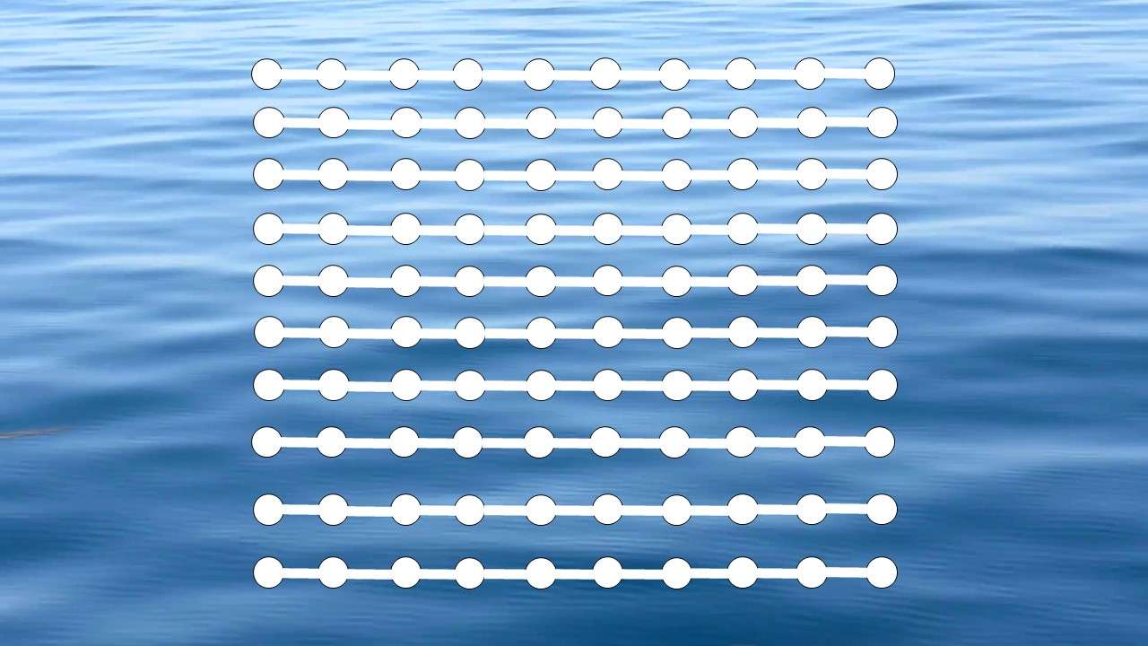

Using Green’s Law, we find the probable height of the waves near the shore and if the height turns out to be more than 3m, a tsunami might be possible.

We have made certain assumptions in our code. We have assumed that the windspeed will not be affecting the speed and the height of the ocean waves also that the depth of the ocean floor changes sharply near the shore and that the position of the sensors does not change.

We also had wanted to incorporate Machine Learning into our code and for that, we generated some images using an ocean simulator in MATLAB and using those images we thought of using pattern recognition to make a code which could distinguish between a calm weather and tsunami.

We were able to generate images but due to time constraint and lack of information we were not able to integrate Machine Learning into our code.

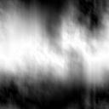 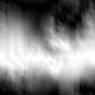

These are images of a calm weather at sea.

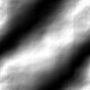 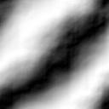

These are the images when a tsunami is possible.

Using such images, we had initially planed of making a code which could have been able to predict tsunamis in a better way by finding the norm of the amplitudes of the wave and checking if the norm was greater than 3m which is the minimum threshold for tsunami waves.



The above image is the image generated for the norm of a condition.

# *File Information*

maincode.class, maincode.ctxt,maincode.java are the program files in JAVA which contain a basic working code.

ocean_simulator.m is a MATLAB script which we used to simulate oceaninc conditions to generate images.

readimage.m is a MATLAB script designed to read images as a step to implement Machine Learning.